**[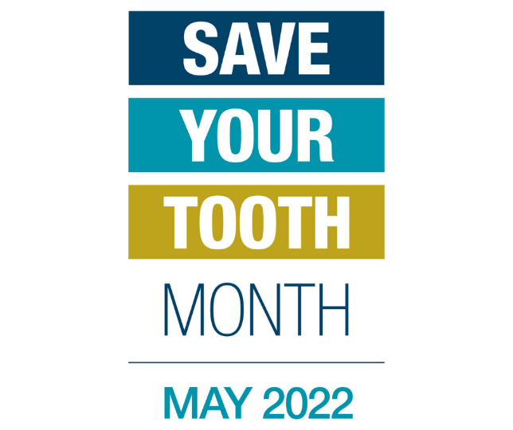](https://www.phoenixendodontist.com/save-your-tooth-month-2022)**

May is Save Your Tooth Month, and we take this time to highlight the importance of retaining natural teeth. Natural teeth allow you bite and chew, but they also retain bone structure in the jaw and face. In addition, nothing beats the natural appearance, feel, and function of a tooth. That is why it is important to keep your teeth healthy with regular brushing, flossing, and six-month dental appointments. Your teeth may, however, develop issues that require extra care. If you are experiencing extreme, prolonged sensitivity to temperature, pain in the tooth and gums, swelling, graying discoloration or a traumatic injury to a tooth, an endodontist can help you save your natural tooth.

Endodontists are specialists in saving teeth, performing root canals and other endodontic treatments. They complete years of training beyond dental school, learning to preserve compromised natural teeth and manage patient discomfort with cutting-edge technology and surgical techniques that allow for precise diagnosis and effective treatment. They are trained to treat oral pain in a way that eases patients’ fears, and their enhanced training and use of the latest technology and best practices in clinical care deliver impressive success rates. An endodontist has probably dealt with a case like yours before. No matter how complex the challenge, it is probably familiar to your endodontist.

Root canals have gained an unfair reputation as a painful, scary and costly procedure. In reality, a root canal performed by a skilled endodontist isn’t painful. If you come in with a painful tooth needing treatment, you’re very likely to leave after the procedure with a significant reduction in pain. In addition, the cost of replacing a missing tooth with bridgework, implant, or partial dentures makes a root canal a cost-effective option. Saving your natural tooth, when possible, is your best option for optimal health and aesthetic results. Nothing works better than your natural teeth, and they are worth saving.

Don’t live with tooth pain, let [Endo Inc. Root Canal Specialists North Shore](https://www.endoincrootcanal.com/) make your smile pain-free. Call us at 978-745-6900 to see how we can help relieve your pain, save your natural tooth and restore your smile!